**CERTIFICATE OF INTERNSHIP**

**Date:** 10/04/2023

This certificate confirms that Lavannya Ghanti, with registration number 1AY20EC407, a student of the Electronics & Communication department (B. Tech) at Acharya Institute of Technology, has completed an internship program at SiyaCon Technologies.

During the internship program, Lavannya Ghanti participated in our VLSI training program and successfully completed it. Her internship took place between August 1, 2022, and August 31, 2022, during which she worked on the topic of "Design of area efficient 10T SRAM cell for biomedical applications."

We are happy to provide any further information or details about Lavannya Ghanti's internship program upon request. We wish her the best of luck in all her future endeavors.

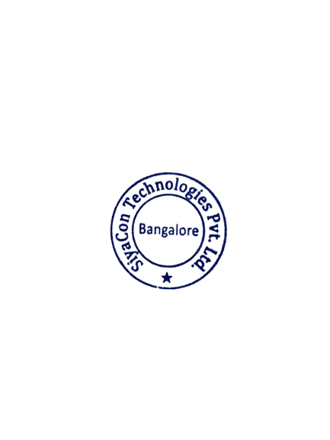Sincerely,

SiyaCon Technologies Pvt. Ltd